**Create a Page Layout using SharePoint Designer**

Open SharePoint designer 🡪 Open Publishing Portal Site collection

Select Page layouts

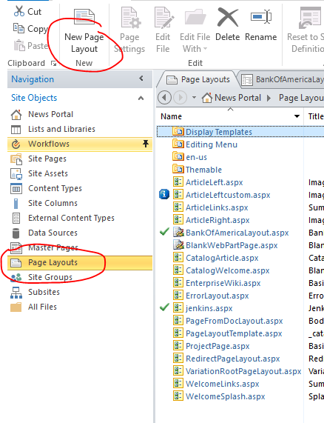

Create New Page Layout

* Enter url BankOfAmericalayout.aspx
* Enter Title Bank Of America layout

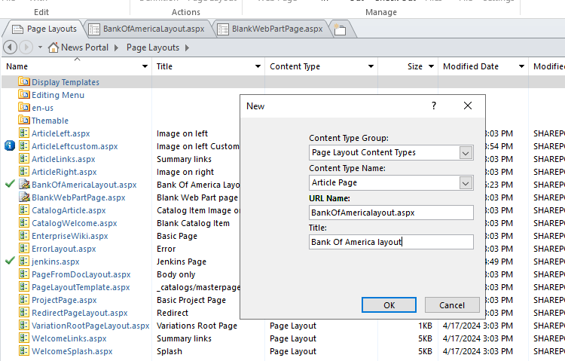

Controls:

* Microsoft.SharePoint.Publishing.WebControls <https://learn.microsoft.com/en-us/previous-versions/office/developer/sharepoint-2010/ms551164(v=office.14)>

# Microsoft.SharePoint.WebControls <https://learn.microsoft.com/en-us/previous-versions/office/developer/sharepoint-2010/ms413880(v=office.14)>

Open the Page layout file and Paste below code inside PlaceHolderMain

<Code>

Save it

**Check in and Publish the Layout**

Open the site in browser and go to sit settings

Select **Master pages and page layouts** under web Galleries

Check in the BankOfAmericalayout.aspx

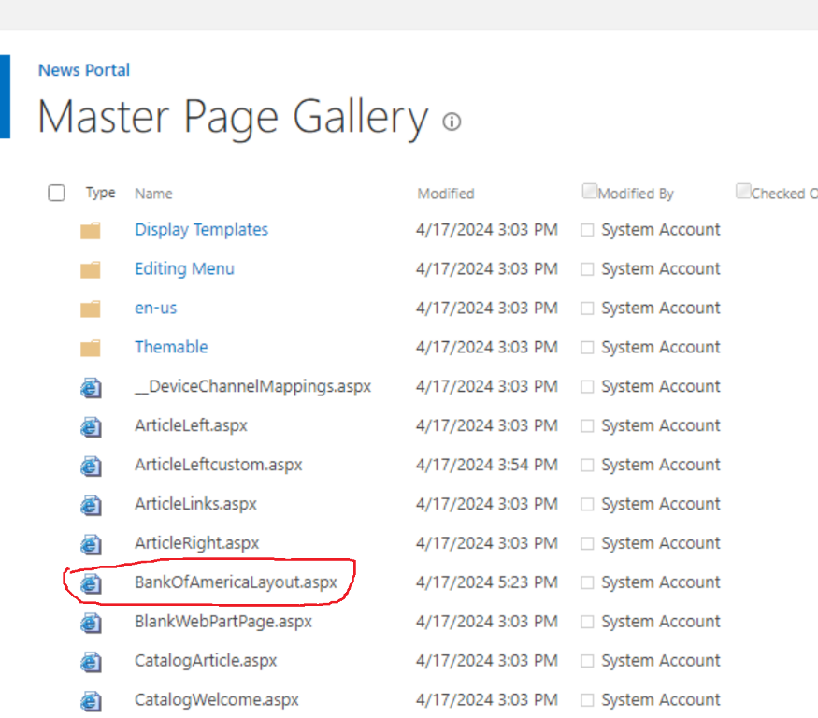

Publish it

**Create a Page using out custom Layout**

Then open Page Library and create new Article page

* select BOA Page layouts

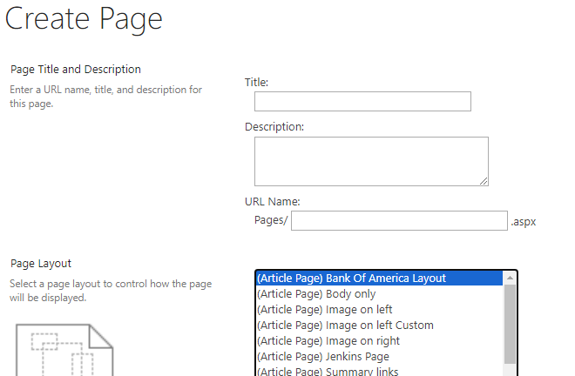

Click Create to create a Page

Add webparts as per your wish

Save it

Publish it

